Narrative: Enhancement Two: Algorithms and Data Structure
SNHU CS 499
Kevin Bristow
- Briefly describe the artifact. What is it? When was it created?
The artifact is a continuation of my digital book library website. The website I am creating is a full-stack application that acts as a digital library/note taking app where users have personal accounts and can add notes for individual books in their library. This tech-stack consists of MongoDB, Express, and NodeJS. My end goal is to have this website hosted for others to use.

- Justify the inclusion of the artifact in your ePortfolio. Why did you select this item? What specific components of the artifact showcase your skills and abilities in algorithms and data structure? How was the artifact improved?
I am creating a full-stack website because I think it will showcase my abilities as a developer – including not only frontend and backend, but my ability to design/plan, deploy to a server, and analyze solutions.
Below are examples of algorithms and data structure implementations that make my website function.
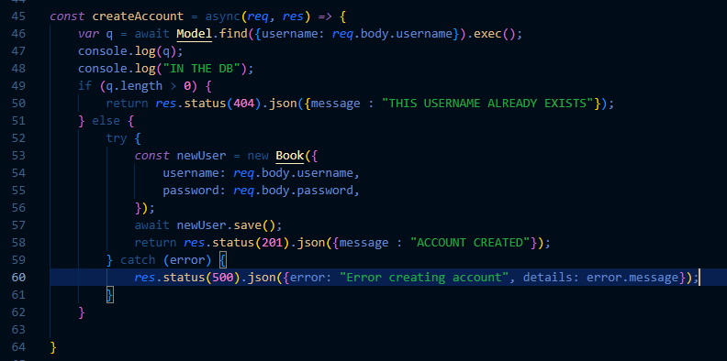
This function queries the database and then creates and saves a new user to it. The algorithm will respond with a status response depending on its success.
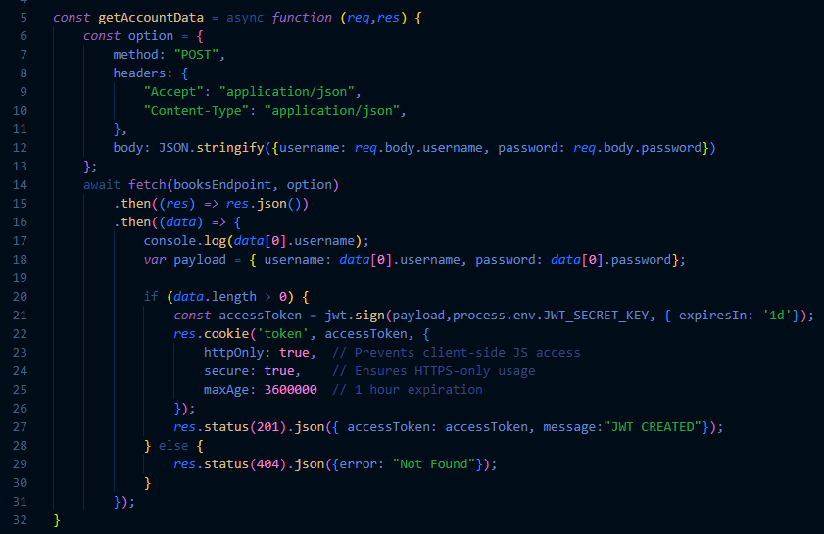
This algorithm utilizes objects (hashmaps) to send data from the client to the server, where the server uses an encryption algorithm to assign a special access token to the client in the form of a json webtoken. This algorithm is a security measure.
- Did you meet the course outcomes you planned to meet with this enhancement in Module One? Do you have any updates to your outcome-coverage plans?
This artifact meets the planned enhancement that was described in Module One. It is meeting the outcome of designing computing solutions to a solve a problem and it being designed with security in mind with the use of validation tokens. So far, all the outcomes have been started, and they will be done when the website is complete.
- Reflect on the process of enhancing and modifying the artifact. What did you learn as you were creating it and improving it? What challenges did you face?
The most challenging part of this is learning how to correctly implement necessary technologies for the website to work. Originally, I thought that a simple username and password system would suffice, but I soon realized that I needed to add a validation layer and that I should also add encryption to stored data as well. In my first major project, I am learning that more is needed than originally thought to make a full-stack app and that I need to be ok with adapting to implementing new technologies.

